# C:\Users\VidyaGxp User 2\AppData\Local\Microsoft\Windows\INetCache\Content.Word\logo.png

# Document Comparison Pro

Start - User Guide

## Table of Contents

1. **Introduction** .............................................................................................1  
   1.1 Overview .............................................................................................1  
   1.2 Key Features ........................................................................................1  
   1.3 Target Audience ..................................................................................2
2. **System Requirements** ..............................................................................2  
   2.1 Minimum Technical Requirements .....................................................2  
   2.2 Server Requirements (For Installation on Client Servers) ...................3
3. **Accessing Document Comparison Pro** ...................................................3  
   3.1 Logging In ...........................................................................................3  
   3.2 Forgot Password ..................................................................................4
4. **User Roles and Permissions** ....................................................................4  
   4.1 Overview .............................................................................................4  
   4.2 User Roles ...........................................................................................5  
   4.3 Managing Permissions ........................................................................5
5. **Uploading and Managing Documents** ...................................................5  
   5.1 Uploading Files ...................................................................................6  
   5.2 Supported File Formats .......................................................................6  
   5.3 Document Validation ...........................................................................7
6. **Performing Document Comparisons** .....................................................7  
   6.1 Comparing Documents ........................................................................7  
   6.2 Report Generation ...............................................................................8  
   6.3 Comparing Multiple Versions .............................................................8
7. **Viewing and Managing Reports** .............................................................9  
   7.1 Accessing Comparison Reports ...........................................................9  
   7.2 Sharing Reports .................................................................................10
8. **User Management (Admin Only)** .........................................................10  
   8.1 Adding New Users ............................................................................10  
   8.2 Editing User Permissions ..................................................................11
9. **Troubleshooting and Support** ..............................................................11  
   9.1 Common Issues .................................................................................11  
   9.2 Technical Support ..............................................................................12
10. **Additional Features** ...............................................................................12  
    10.1 Version History ...............................................................................12  
    10.2 Customizable Reporting ..................................................................13

**1. Introduction**

**Overview**

**Document Comparison Pro** is an advanced software solution designed to facilitate seamless and accurate comparisons between multiple document types, such as PDFs and Word files. This tool is ideal for professionals, such as legal teams, editors, and document management experts, who require robust version control and document comparison features.

With its intuitive user interface, flexible comparison options, and detailed reporting, **Document Comparison Pro** ensures that users can efficiently track changes between different versions of documents, identify differences, and generate actionable reports for further analysis.

**Key Features**

* **Multiple File Formats**: Supports the comparison of PDFs, Word documents, Excel, and more.
* **Detailed Comparison Reports**: Color-coded reports that clearly outline added, removed, or changed content.
* **User-Friendly Interface**: Easy drag-and-drop upload, navigation, and comparison features.
* **Version Tracking**: Keep track of document versions and view changes over time.
* **Secure and Customizable Permissions**: Role-based access for uploading, comparing, and viewing documents.
* **Scalability**: Capable of handling multiple users, large files, and bulk document uploads.

**Target Audience**

This software is designed for:

* **Pharmaceutical Documents**: To compare lab documents, legal documents, and case files.
* **Editing and Publishing**: To review changes across versions of manuscripts, articles, or research papers.
* **Business Professionals**: To manage version control for business documents and proposals.

**2. System Requirements**

**2.1 Minimum Technical Requirements**

To use **Document Comparison Pro**, the following minimum system requirements should be met:

* **Browser**: Google Chrome, Mozilla Firefox, Microsoft Edge, or Safari (latest versions).
* **Operating System**: Windows 10, macOS 10.15+, or Linux.
* **Internet**: A stable internet connection (minimum 5 Mbps) is recommended for optimal performance.

**2.2 Server Requirements (For Installation on Client Servers)**

* **Operating System**: Ubuntu 18.04+ or CentOS 7+.
* **Database**: PostgreSQL 12+, MySQL 8.0+, or other compatible databases.
* **Web Server**: Apache 2.4+ or Nginx.
* **Python**: Python 3.7+ (Django 3.2+ framework).
* **Storage**: Ensure ample storage based on the volume of documents and comparisons (starting at 50 GB recommended for smaller businesses).

**3. Accessing Document Comparison Pro**

Once the system is set up, users can access the software via a web browser:

1. Open your preferred web browser.
2. Enter the provided URL in the address bar (e.g., <https://www.document.vidyagxp.com>).

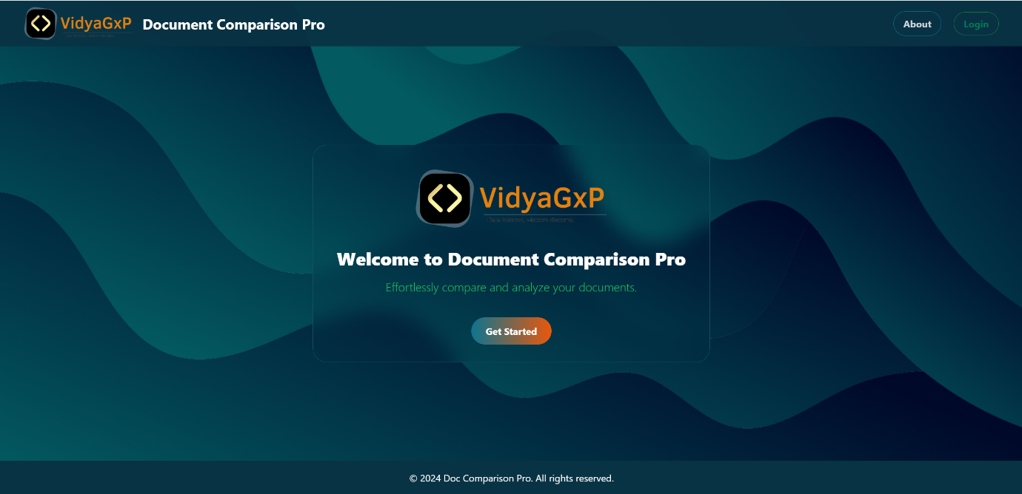

**3.1 Logging In**

Once the users have valid credentials of the software via a web browser:

1. Enter your **username** and **password** on the login page.
2. Click **Login** to access your personalized dashboard.

**Note**: For first-time users, credentials will be sent via email by the system administrator.

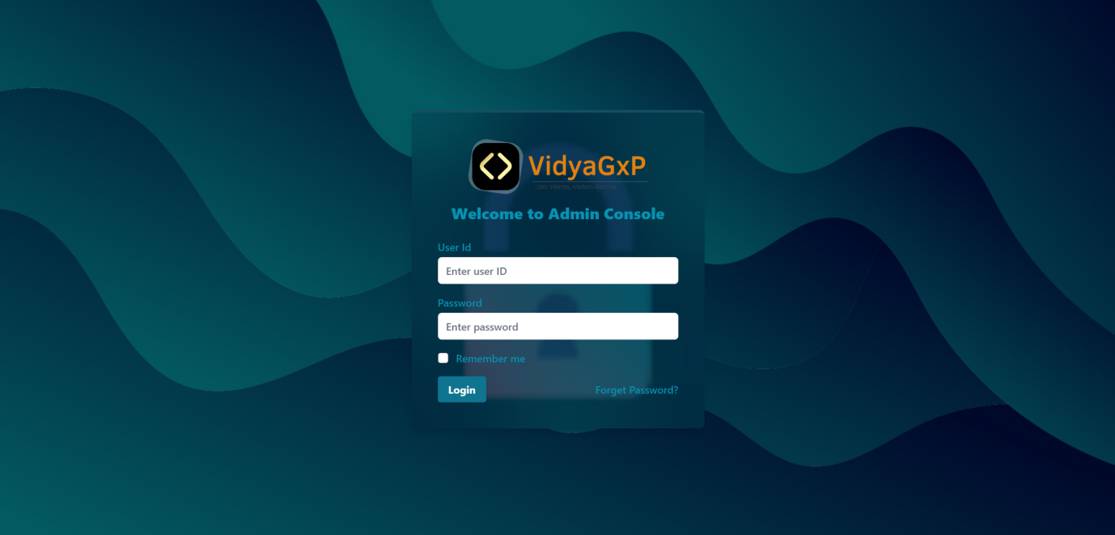

**3.2 Forgot Password**

If you have forgotten your password:

1. Click **Forgot Password** on the login screen.
2. Enter your registered email address.
3. Check your inbox for the password reset link.
4. Follow the instructions to reset your password.

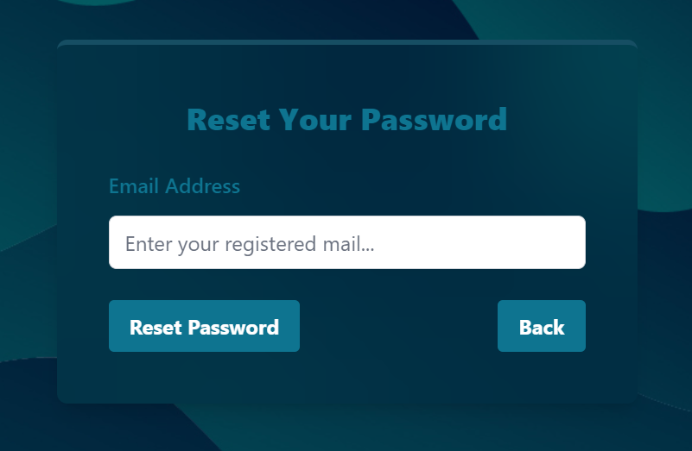

**4. User Roles and Permissions**

**4.1 Overview**

**Document Comparison Pro** allows administrators to assign various roles to users, with specific permissions controlling their level of access. The system supports role-based permissions, ensuring document security and user accountability.

**4.2 User Roles**

* **Administrator**: Full control over the system, including user management, permission assignment, and document uploads.
* **Editor**: Can upload, edit, and compare documents but has no control over user management.
* **Viewer**: Can view comparison reports but cannot upload or edit documents.

**4.3 Managing Permissions**

Admins can assign the following permissions:

* **Upload Documents**: Allow users to upload new files to the system.
* **Compare Documents**: Allow users to run comparisons between uploaded documents.
* **View Reports**: Allow users to view and download the comparison reports.
* **Manage Users**: Grant the ability to add, edit, or delete users from the system.

To manage permissions:

1. Go to the **User Management** section.
2. Select the user you wish to modify.
3. Assign the desired permissions using the provided checkboxes.

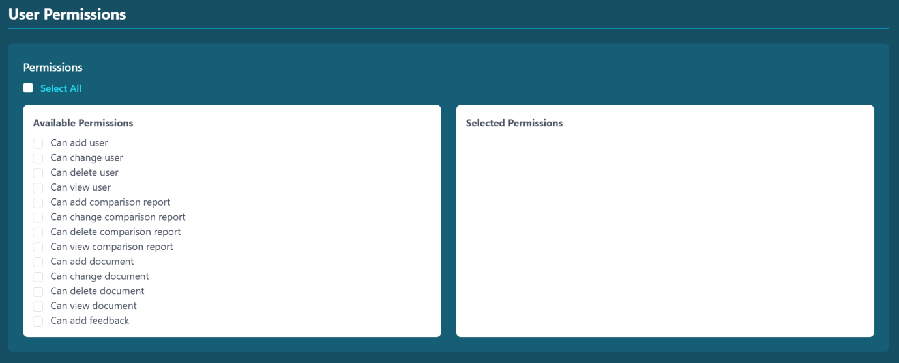

**5. Uploading and Managing Documents**

**5.1 Uploading Files**

The document upload feature allows users to submit multiple files for comparison. Users can upload documents in bulk or individually.

**Step-by-Step Process:**

1. From the dashboard, navigate to the S**tart Comparison** section.
2. Click **Browse Files** or drag-and-drop your files into the upload area.
3. Multiple files can be uploaded at once, but ensure that each file is under the maximum size limit (default: 25MB per file).
4. Click **Upload** to submit the files for processing.
5. After successful upload, the documents will appear in the **Document Library** for comparison.

**5.2 Supported File Formats**

* PDF (.pdf)
* Microsoft Word (.docx)
* Text Files (.txt)

*Note*: Ensure files are properly formatted and not corrupted before uploading.

**5.3 Document Validation**

During the upload process, the system automatically checks:

* File format (supported formats only).
* File size limits.
* Document integrity (ensuring no errors during the comparison).

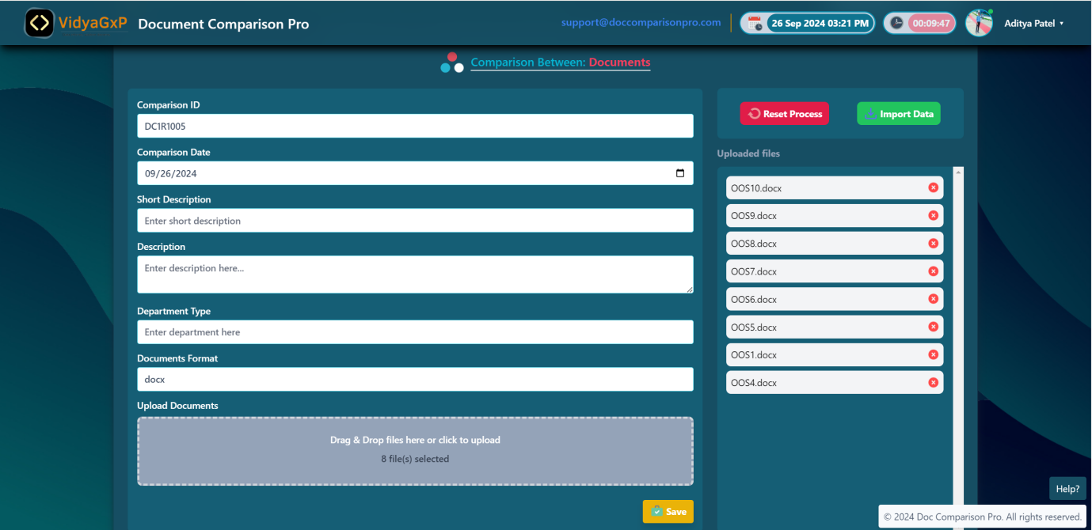

**6. Performing Document Comparisons**

**6.1 Comparing Documents**

Users can compare two or more documents at once to identify differences. The system offers flexible comparison options.

**Step-by-Step Process:**

1. Go to the **Start Comparison** section from the dashboard.
2. Select the documents you want to compare by checking the boxes next to each document.
3. Choose the **Comparison Type**:
   * **Content Comparison**: Compares the text and structure of the documents.
   * **Layout Comparison**: Identifies changes in formatting and layout (e.g., headers, tables, footnotes).
4. Click **Compare Now**. The system will generate a detailed report.
5. View the report immediately on the dashboard or download it as a PDF.

**6.2 Report Generation**

Once the comparison is complete, a report is automatically generated with the following features:

* **Color-coded differences**:
  + **Red**: Removed text or sections.
  + **Blue**: Modified or changed text.
  + **Green**: Added text or sections.
* **Interactive Comparison Viewer**: Allows users to scroll through documents side-by-side for real-time comparison.
* **Downloadable Reports**: Export reports as PDF for record-keeping or sharing.

**6.3 Comparing Multiple Versions**

You can compare more than two versions of the same document to track changes over time. The system will display cumulative differences across the versions.

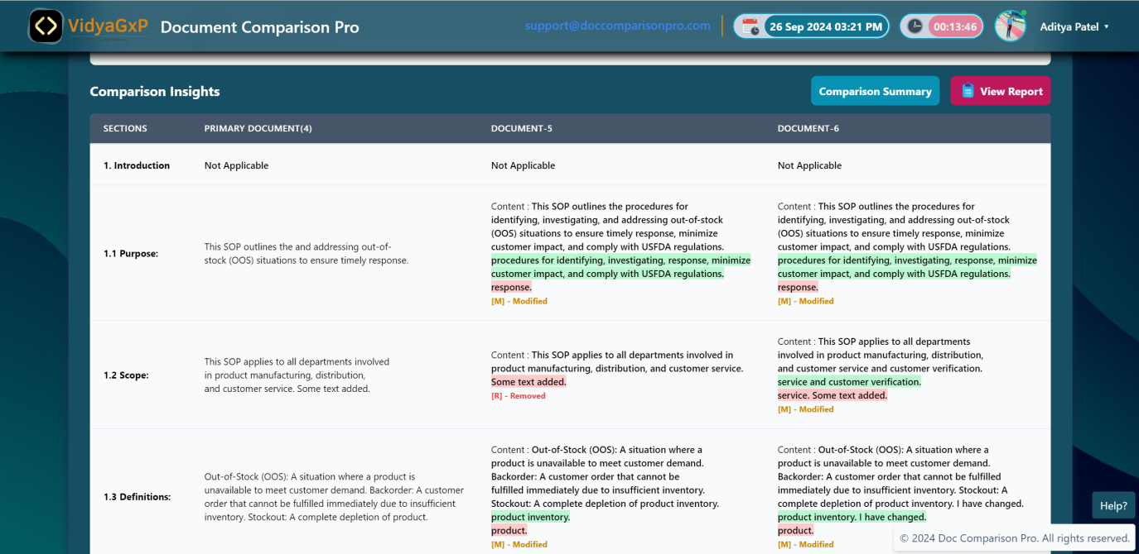

**7. Viewing and Managing Reports**

**7.1 Accessing Comparison Reports**

All reports generated from document comparisons are accessible from the **Comparison Reports** section. Users can:

* View the report in real-time.
* Download reports in PDF format for offline review.

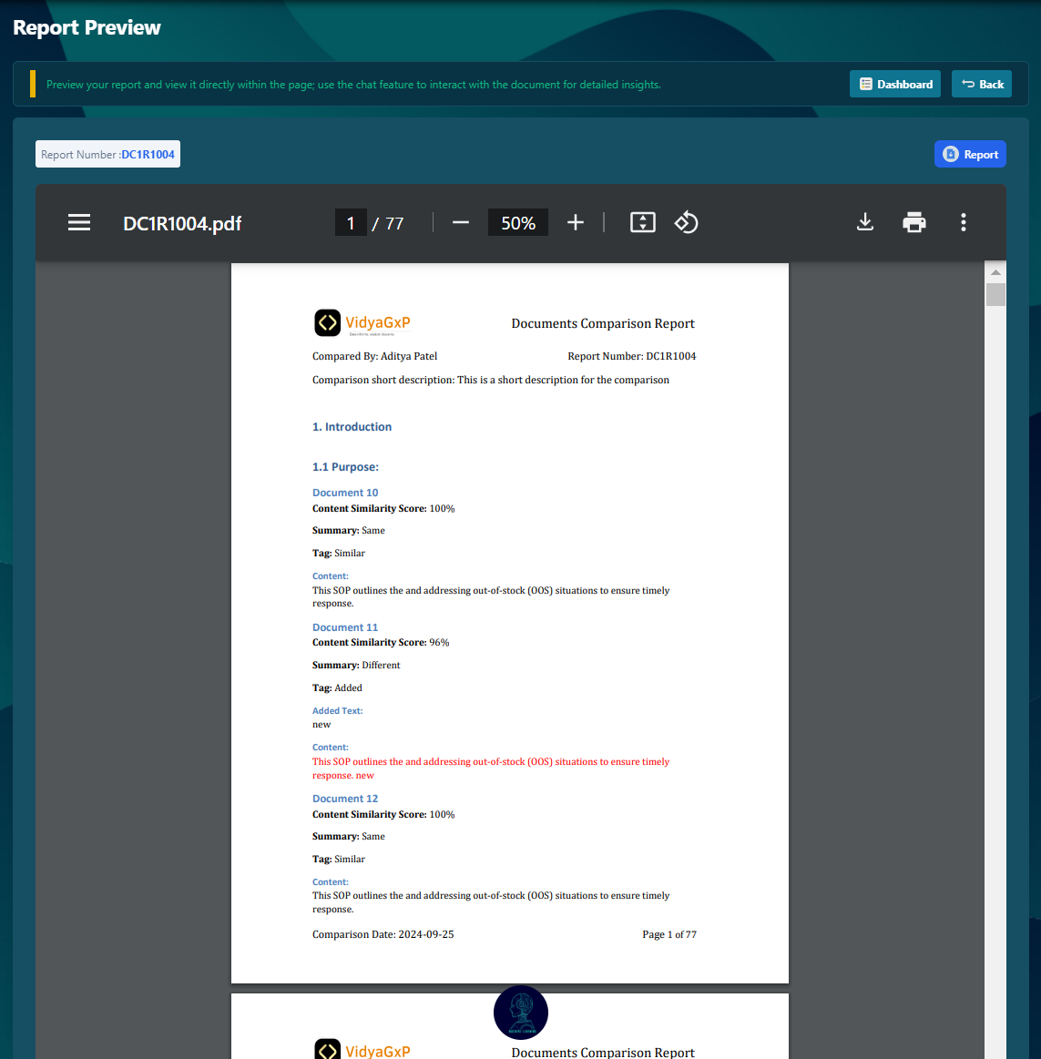

**7.2 Sharing Reports**

Users with appropriate permissions can share reports via email or export the reports as PDF files for distribution.

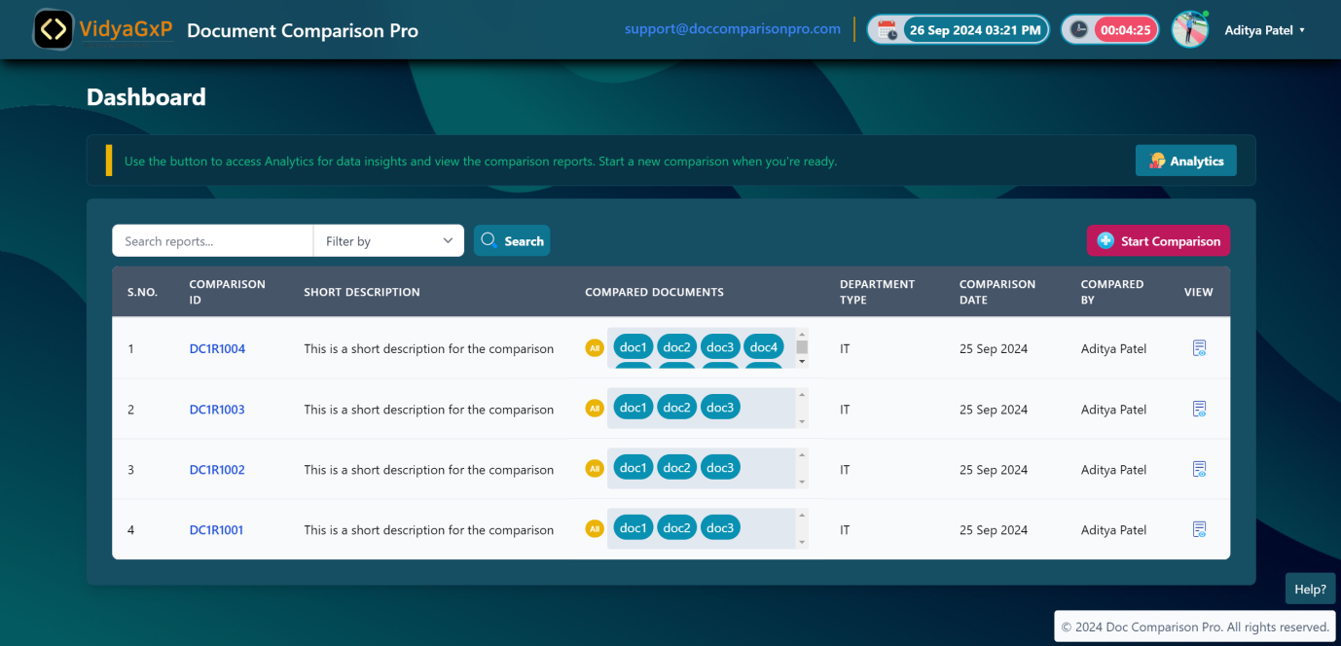

**8. User Management (Admin Only)**

**8.1 Adding New Users**

To add new users:

1. Go to the **User Management** section.
2. Click **Add New User**.
3. Fill in user details such as name, email, and role.
4. Assign permissions based on the role.
5. Click **Save** to create the new user.

**8.2 Editing User Permissions**

1. Go to the **User Management** section.
2. Select the user whose permissions you want to modify.
3. Adjust permissions as needed.
4. Click **Save** to apply changes.

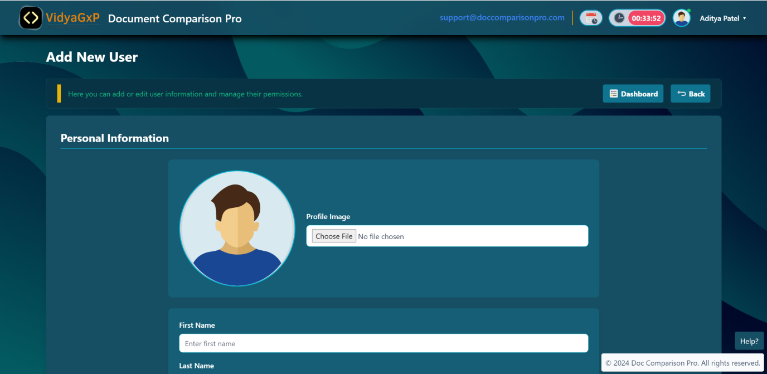

**9. Troubleshooting and Support**

**9.1 Common Issues**

**Q: I can’t upload my document. What could be the issue?**  
A: Ensure that the file format is supported and the file size does not exceed the system limit (default: 25MB per file). Also, verify that your internet connection is stable.

**Q: I’m unable to compare documents. What should I do?**  
A: Check if you have the required permissions to perform document comparisons. If the issue persists, contact your system administrator.

**Q: How do I reset my password?**  
A: Click **Forgot Password** on the login screen and follow the instructions sent to your email.

**9.2 Technical Support**

For any technical issues or further assistance, contact our support team:

* **Email**: support@documentcomparisonpro.com
* **Phone**: +1-800-123-4567
* **Hours**: Monday to Friday, 9:00 AM - 6:00 PM (EST)

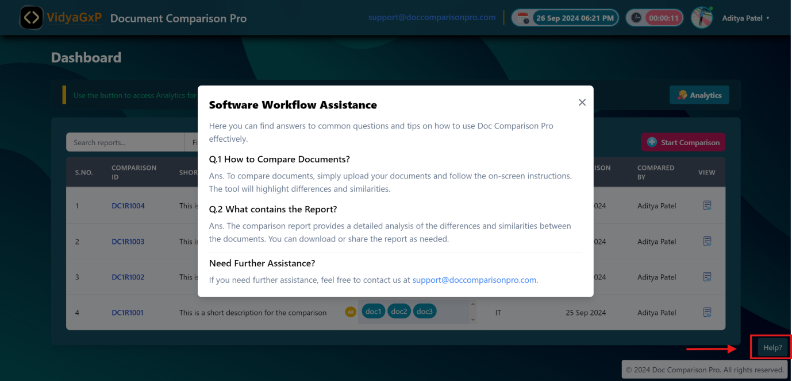

**10. Additional Features**

**10.1 Version History**

* Track document versions over time.
* Compare any version with the current document for precise tracking of changes.

**10.2 Customizable Reporting**

* Export reports in various formats (PDF, CSV, etc.).
* Customize reports based on specific needs or requirements (legal, editorial, etc.).